**WEG launches new compact motor protection circuit breaker**

WEG, a leading global manufacturer of motor and drive technology, has launched the most compact Class-10 motor circuit protective circuit breaker available on the market – the MPW80 – to meet the needs of applications requiring high short-circuit switching capacity and space-saving installation. The new MPW80 reliably protects motors against overload and short circuit conditions and provides phase loss sensitivity according to IEC 60947-4-1 standards, enabling plant engineers to increase the uptime of their operations. The circuit breaker can also protect against voltage dips and interruptions with the addition of optional accessories.

“In line with our commitment to strengthening our automation offering, WEG has developed the MPW80 motor protection circuit breaker to offer very compact design, high robustness and high reliability,” says Zoltan Schaaf, Manager Low Voltage Switchgear at WEG. “As such, the MPW80 helps users across a broad range of industrial applications benefit from maximum operational reliability even under the most demanding conditions.”

The user-friendly MPW80 is designed for rated operating currents from 32 to 80 A and to interrupt short-circuit currents up to 65 kA at 415 V. It has clear position indications on the device for On, Off and Tripped, so users can see at quick glance the status of the circuit breaker. In addition, the motor protection circuit breaker features temperature compensation from -20°C to +60°C, which ensures consistently high tripping accuracy over the entire range.

The MPW motor protection circuit breakers are compatible with WEG’s CWB series of motor contactors so compact and effective motor starter combinations can easily be assembled using mounting adapters. The MPW80i version can also be used to protect non-motor loads, such as resistive loads or short circuit protection in a starter combination, while providing the advantages of electronic motor protection devices.

WEG has also developed uniform accessories for all its motor protection circuit breakers (types MPW18, -40 and -80) to reduce stock diversity, meaning engineers can simplify their procurement process. With the relevant accessories, users can receive differentiated tripped signals conveniently at remote locations.

The MPW80 motor protection circuit breaker is manufactured and tested in accordance with the IEC/EN 60947 standard (DIN VDE 0660). The device is also available with UL/CSA approval for use in the North American market. All of WEG’s motor protection circuit breakers can be used to switch and protect IE3 motors, as clearly indicated by the ‘IE3 CONFORM’ logo on the package.

For more information on WEG’s energy efficient drive solutions visit [www.weg.net/uk](http://www.weg.net/uk).

**Image captions:**

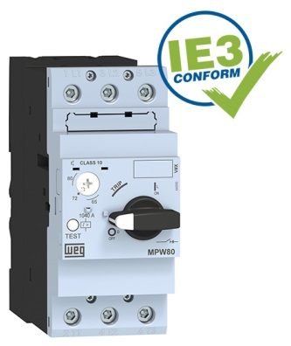

**WEG000599_Image 1:** The new MPW80 motor protection circuit breaker for rated continuous current from 32 to 80 A

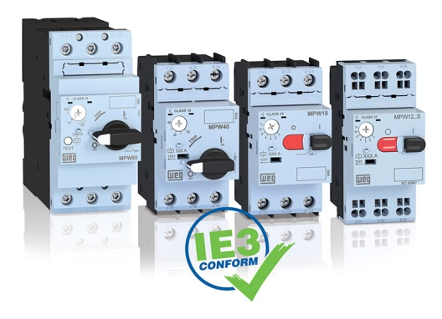

**WEG000599_Image 2:** The overall MPW series is suitable for operating and protecting motors with continuous operating current from 12 to 100 A (types MPW12, -18, -40 and -80 shown here)

Follow WEG at  Description: Description: Description: Description: Description: Description: Description: Description: Description: Description: Description: Description: Description: Description: Description: Description: Description: Description: Description: Description: Description: Description: Description: Description: Description: Description: Description: Description: Description: Description: Description: Description: Description: Description: Description: Description: Description: Description: Description: Description: Description: Description: Description: Description: Description: Description: Description: Description: Description: cid:image009.jpg@01CE8155.D3CFD760   Description: Description: Description: Description: Description: Description: Description: Description: Description: Description: Description: Description: Description: Description: Description: Description: Description: Description: Description: Description: Description: Description: Description: Description: Description: Description: Description: Description: Description: Description: Description: Description: Description: Description: Description: Description: Description: Description: Description: Description: Description: Description: Description: Description: Description: Description: Description: Description: Description: cid:image011.jpg@01CE8155.D3CFD760  Description: Description: Description: Description: Description: Description: Description: Description: Description: Description: Description: Description: Description: Description: Description: Description: Description: Description: Description: Description: Description: Description: Description: Description: Description: Description: Description: Description: Description: Description: Description: Description: Description: Description: Description: Description: Description: Description: Description: Description: Description: Description: Description: Description: Description: Description: Description: Description: Description: cid:image010.jpg@01CE8155.D3CFD760

**About WEG**

WEG is one of the largest global manufacturers of electric equipment, having five main Business Units: Motors, Energy, Transmission and Distribution, Automation and Coatings.  The company employs over 31,000 people worldwide and in 2014 achieved global sales of R$7.8 billion, representing success across a wide range of product groups.  These include the latest generation of transformers, LV control gear, generators, gear motors, inverter drive systems, soft starters, LV/MV and HV motors, ATEX-compliant explosion proof motors, smoke extraction motors and full turnkey systems.

Its power generation, transmission and distribution solutions enable those across many industries, especially in the oil & gas, water, power distribution, chemical and petrochemical markets, to operate more efficiently, and to reduce energy usage, carbon emissions and environmental impact. In addition, WEG provides full solutions for renewable energy projects, producing complete wind turbine and solar energy systems.

**Editorial Contact**

Marco Giudici, Technical Publicity  
Tel: +44 (0)1582 390991   
Email: [mgiudici@technical-group.com](mailto:mgiudici@technical-group.com)

**Company Contact**

Marek Lukaszczyk, WEG (UK) Ltd   
Tel: +44(0)1527 513800 Fax: +44(0)1527 513810  
Email:  [wegsales@wegelectricmotors.co.uk](mailto:sclarke@technical-group.com)

Web: [www.weg.net](http://www.weg.net)/uk