**New series of circuit breakers launched**

***The circuit breakers in the DWB series are suitable for a wide range of applications.***

WEG, a leading worldwide vendor of drive technology, is launching the DWB series of modular circuit breakers in Europe. They are designed with rated operating voltages up to 690 V AC or 250 V DC and are available in three-pole and four-pole versions in six case sizes with rated operating currents from 16 to 1,600 A. The DWB molded case circuit breakers can reliably interrupt short-circuit currents up to 80 kA at 415 V to protect plants, equipment, cables and wiring, as well as motors and generators. The circuit breakers feature very compact design, high robustness and high reliability, so users benefit from maximum operational reliability even under the most demanding conditions as well as space-saving installation.

With suitable accessories, the circuit breakers and associated plants, equipment and components can be switched on and off remotely. A uniform range of accessories within the series, including auxiliary switch blocks, undervoltage and shunt opening releases, and phase separators, reduce the require diversity of parts stock. That has a positive impact on stock management, type selection and detail engineering.

The modular design of the DWB series allows the complexity of the circuit breakers to be adapted to the requirements of specific application areas. For example, the needs of simple cost-sensitive applications can be met using circuit breakers with fixed overload and short-circuit tripping mechanisms based on the thermal-magnetic operating principle. By contrast, circuit breakers with adjustable overload and short-circuit tripping mechanisms can be deployed in more sophisticated solutions. Circuit breakers with adjustable current-dependent or time-delayed overload and short-circuit tripping using electronic tripping mechanisms are available to meet complex requirements. These versions can be used to construct selective protections networks in order to constantly ensure that only the circuit breaker directly ahead of the fault location is tripped and all other parts of the network are reliably supplied with power.

Four-pole circuit breakers are available with and without neutral conductor protection. Versions without overload tripping can be used to protect non-inductive loads. Versions without overload tripping are also used in starter combinations, with the circuit breaker providing short-circuit protection and a separate overload relay providing overload protection. Electronic overload relays with a wide variety of protective effects are also frequently used in this connection.

Additionally, power disconnectors are available for effective interruption of power circuits. The circuit breakers in the DWB series are manufactured and tested in accordance with the IEC/EN 60947 standard (DIN VDE 0660) and the latest state of the art.

Follow WEG on  Description: Description: Description: Description: Description: Description: Description: Description: Description: Description: Description: Description: Description: Description: Description: Description: Description: Description: Description: Description: Description: Description: Description: Description: Description: Description: Description: Description: Description: Description: Description: Description: Description: Description: Description: Description: Description: Description: Description: Description: Description: Description: Description: Description: Description: Description: Description: Description: Description: cid:image009.jpg@01CE8155.D3CFD760   Description: Description: Description: Description: Description: Description: Description: Description: Description: Description: Description: Description: Description: Description: Description: Description: Description: Description: Description: Description: Description: Description: Description: Description: Description: Description: Description: Description: Description: Description: Description: Description: Description: Description: Description: Description: Description: Description: Description: Description: Description: Description: Description: Description: Description: Description: Description: Description: Description: cid:image011.jpg@01CE8155.D3CFD760  Description: Description: Description: Description: Description: Description: Description: Description: Description: Description: Description: Description: Description: Description: Description: Description: Description: Description: Description: Description: Description: Description: Description: Description: Description: Description: Description: Description: Description: Description: Description: Description: Description: Description: Description: Description: Description: Description: Description: Description: Description: Description: Description: Description: Description: Description: Description: Description: Description: cid:image010.jpg@01CE8155.D3CFD760

**Figure captions:**

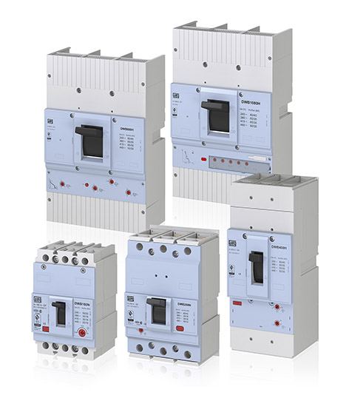

**WEG000851_Bild1:** The DWB series of molded case circuit breakers with rated operating currents from 16 to 1,600 A provide effective protection for plants, equipment, cables, wiring, motors and generators.

## About WEG

WEG is one of the largest global manufacturers of electric equipment, having five main Business Units: Motors, Energy, Transmission and Distribution, Automation and Coatings.  The company employs over 30,000 people worldwide and in 2015 achieved global sales of US$ 3.34 billion, representing success across a wide range of product groups.  These include the latest generation of transformers, LV control gear, generators, gear motors, inverter drive systems, soft starters, LV/MV and HV motors, ATEX-compliant explosion proof motors, smoke extraction motors and full turnkey systems.

Its power generation, transmission and distribution solutions enable those across many industries, especially in the oil & gas, water, power distribution, chemical and petrochemical markets, to operate more efficiently, and to reduce energy usage, carbon emissions and environmental impact. In addition, WEG provides full solutions for renewable energy projects, producing complete wind turbine and solar energy systems.

**Editorial Contact**

Marco Giudici, Technical Publicity  
Tel: +44 (0)1582 390991   
Email: [mgiudici@technical-group.com](mailto:mgiudici@technical-group.com)

**Company Contact**

Marek Lukaszczyk, WEG (UK) Ltd   
Tel: +44(0)1527 513800 Fax: +44(0)1527 513810  
Email: [wuk-enquiry@weg.net](mailto:wuk-enquiry@weg.net)

Web: [www.weg.net](http://www.weg.net)/uk